



Befriending at The Isaiah Project

Contents

What is Befriending?
Building a Strong Relationship
Communication
Boundaries
Matching Process
Confidentiality and Reporting Procedures
Prayer Requests
Office Support (lead befriender, finance, properties, SEA, volunteering)

What is Befriending?

Befriending is about listening and supporting another person.
Befriending is about acceptance and choice, not about creating dependence.
Befriending is about offering positive and regular contact.
Befriending is about reducing social isolation, improving self-esteem and confidence, reducing vulnerability and improving social skills.
Befriending is being a friend in a professional capacity.
It is not about replacing social care requirements, solving someone’s problems or friendship in the traditional sense.

Qualities and Characteristics of Befrienders
There are many qualities and characteristics that create a strong and valuable befriender. Some of them are listed below:
- Strong listening skills
- Ability to approach new people without prejudice
- Honesty and trustworthiness
- Commitment and reliability
- Respect for confidentiality
- Friendliness and warmth
- Empathy and resilience
- Professional approach to working with the organisation
- Ability to offer a caring and understanding presence

Reasons to Become a Befriender
- Be part of a community
- To do something new
- To do something meaningful
- Gain support experience
- To help others

Understanding Marginalisation
The Isaiah Project works with people who, as well as being lonely or socially isolated, may have become marginalised in our society for one reason or another. They may have experienced prejudice and discrimination and often their access to help and support may be limited because of myths and misinformation.

We all have a set of personal values which may change over time and some of which we may uphold more passionately than others. We all have a number of core beliefs about what is ok and what isn’t and these underpin who we are as well as inform how we operate in our daily lives.

As a befriender it is important that your own set of personal values do not affect your ability to support our residents on their own terms. The resident should be in the driving seat of their own life and will have their own set of values. As a befriender we need to respect their opinions, get to know them and help them to move on in their lives. This non-judgemental attitude is not always easy to carry out, but it is essential in building a successful befriending relationship.

Property Checks
The Isaiah Project is a Supported Exempt Landlord, and one of our roles is to help our residents maintain their property well. Whilst on your visits please check the cleanliness / tidiness of the property. If your residents need help with this, your role is to work alongside them to show them how they can manage their property better. If you feel your resident needs more help with this, we can try and arrange a cleaner for them. We also complete a monthly property inspection sheet that needs to be sent to the office.

If there is a deterioration in their living conditions, please consider whether there are other factors affecting this, e.g. mental / physical health.

If your resident has a garden we must also make sure this is well maintained. If they need equipment to help them we can organise this and, where necessary, find someone to give them a hand with the gardening.

Everyone needs other people, but not everyone has someone.

As a Befriender you will offer supportive, reliable relationships to people who may otherwise be alone. The Isaiah Project supports a wide range of needs - families, people with mental ill-health, people suffering trauma, people with disabilities or people who are simply lost.

The results of befriending can be very significant, providing people with a new direction in life, opening up a range of activities and so leading to increased self-esteem and self confidence. However, The Isaiah Project offers more than this - we offer prayer.

Building a Strong Relationship

There are many factors and responsibilities which are important to building your befriending relationships. The following eight steps are useful to reflect upon. Think about relationships that you have had either personally or professionally and how these eight steps have played a part.

Establishing Trust  Your resident should feel able to talk openly about problems and issues. Trust may be an issue as they may have past experiences where their trust has been badly abused. Building trust can take time and should not be rushed. | Encouraging Participation  Crucial for self-development and empowerment. Your resident should be an active partner in the relationship rather than a passive participant. How you respond and how you involve them is part of this and requires sensitivity. | Tackling Challenges  The ability to tackle challenges can be crucial for self development and increasing self-esteem. Resilience grows when we overcome difficulties. Sensitively judging the appropriate level of risk is important so as not to set ourselves up to fail.
Create New Opportunities  As well as attending events planned by Isaiah, you should support your resident to seek new solutions and possibly engage in new activities and hobbies. |  | Creating Equality  This involves respecting, appreciating and accepting the resident as the individual they are. Your befriending relationship should focus on ‘being with’ and ‘not doing for’.
Allowing Choice  We cannot make decisions for our residents. We can discuss things and advise, but as adults they need to make their own choices. | Understanding the Whole Person  This is key. See your resident as a whole person, not just a list of problems. It is about viewing the resident in context, in all the different aspects of their life. | Having Fun  Never underestimate the importance of just having a laugh and a good time.

As a befriender, it is important to remember that you can play a massive part in your resident’s life by helping to grow their confidence and lowering their risk of social isolation. You have the ability to make a large impact on their life.

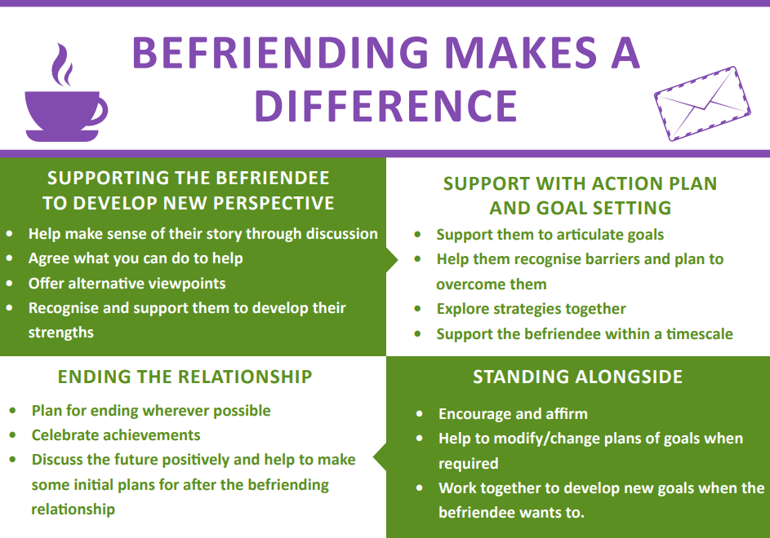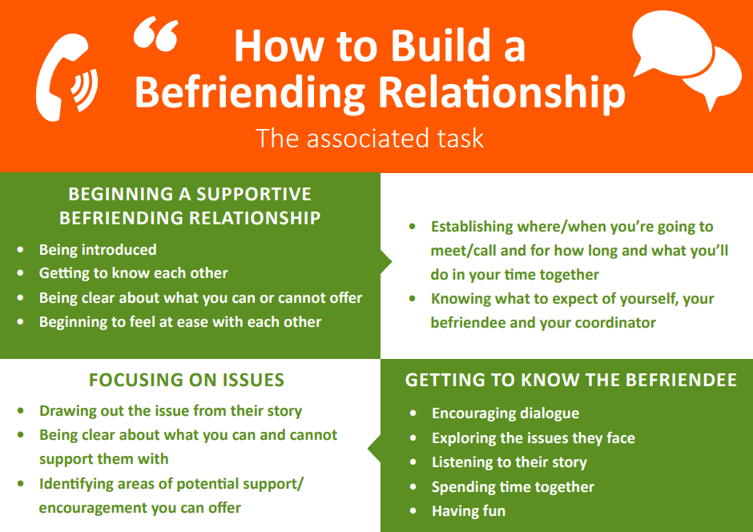

Communication

Good communication skills – the ability to listen and speak to people appropriately and do the right things while we’re listening and speaking – are at the very heart of befriending. We often work with people who have little opportunity to experience someone capable of really listening to them and taking care to communicate accurately and with respect.

Barriers to Effective Communication
In any situation there can be things which prevent good communication from taking place. These are barriers to communication, and they can be either external or internal.

External Barriers | Internal Barriers
Factors outside yourself which mean that you cannot listen, speak or react to the other person as well as you should. E.g. noisy traffic, distractions | Internal barriers are factors inside yourself which prevent you from interacting in the best way. E.g. financial worries

Verbal Communication
Communication is partly about words, and this is what we mean by verbal communication. We speak or write to other people using words and we must select the best ones for the job, or the communication will not be very effective. However, your words are not the most important part of communication. There is also tone and pace (especially if befriending over the phone), and body language for face-to-face befriending either 1:1 or in groups.

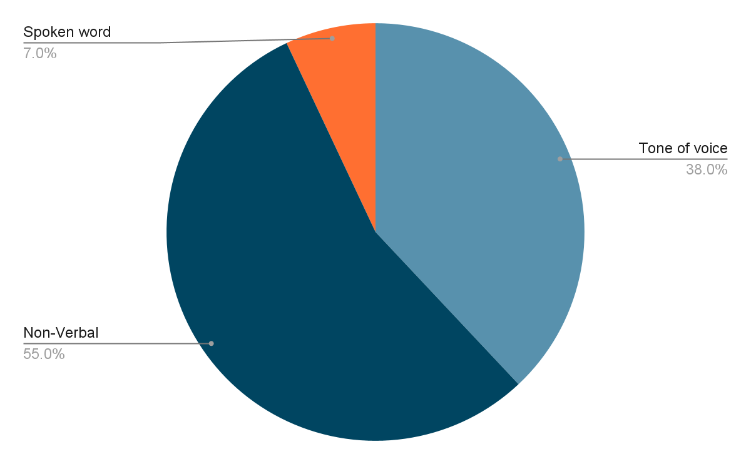
Using your voice for good communication comes down to thinking about four different areas, known as RSVP.

R - Rhythm, hesitations & fluency
S - Speed and pace
V - Volume and clarity
P - Pitch and tone

Active Listening
In terms of making the verbal side of communication go as well as possible, the technique known as active listening is useful to know. With this technique, you understand accurately what the person speaking to you is trying to say and it reassures them that you are listening and that their voice and opinion matters.

In active listening, the listener continually checks back with the person speaking to make sure they have understood the message correctly. It comprises of four steps, which go on continually during the listening process:
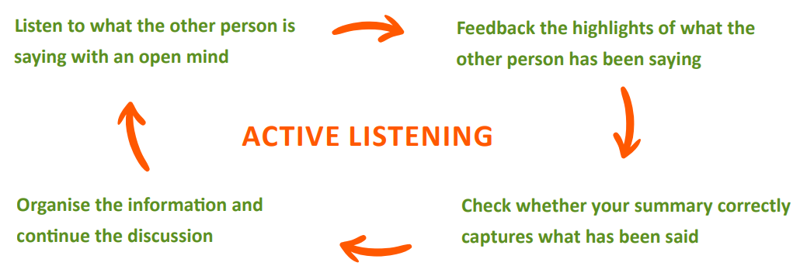

The diagram demonstrates how active listening can contain four parts but that this is a cycle, not a one-time action. By highlighting the information back to the speaker, you are informing them that you have paid attention and taken a genuine interest in what they are saying. This simple step can result in boosting their confidence, making them feel valued and appreciated.

Some Common Problems with Listening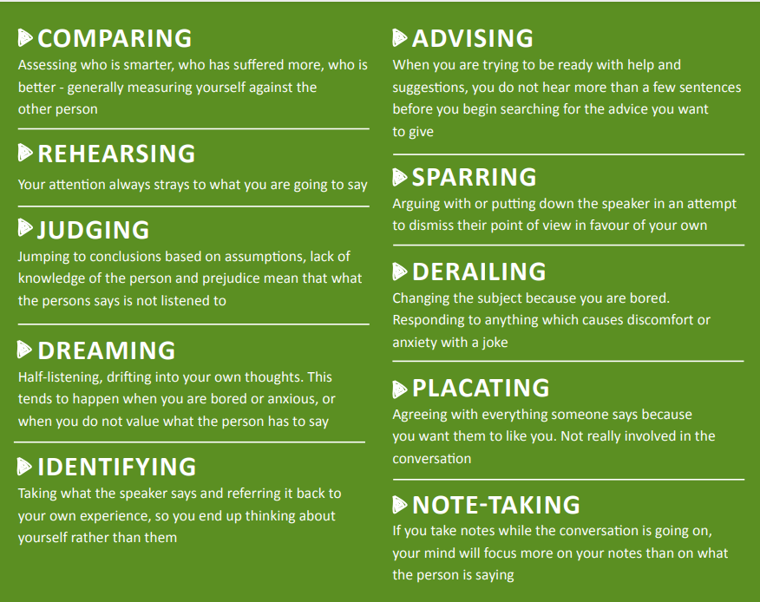

A befriender with good communication skills can:
- Improve the well-being of their resident and help them feel valued
- Broaden the resident’s worldview and their own
- Help to build trust with the resident
- Allow their resident to feel confident about sharing sensitive things
- Assist your resident in feeling less isolated and lonely
- Help to improve their physical and mental health of their resident

Boundaries and Confidentiality

The boundaries in befriending are the guidelines that set out what is ok and what is not ok in a befriending relationship. Befriending relationships are unique in being both personal and professional at the same time, so this relationship has the potential to be confusing. This makes it even more important that boundaries are established, understood, communicated and maintained – for the sake of our residents, our befrienders and for The Isaiah Project itself.

Our project is different from many befriending services in that our residents can be part of the project for many years and so the befriending relationship can last a lot longer than others offer. Our goal is that our residents become part of the Isaiah family, and whilst this gives us the opportunity to have a real positive impact it can also mean that the boundaries become blurred over time.

Throughout the resident/befriender relationship it is important that professional boundaries are always maintained. The residents on our project are vulnerable and the relevant details of these would have been outlined during the matching process. As a befriender it is vital that nothing you do will place any of our residents, yourselves or The Isaiah Project at risk.

Our Boundary Guidelines
Cash handling - never loan or borrow money from a resident. Never look after money for a resident. All residents are encouraged to pay their rent top ups via bank transfer or through the office. In the rare occasion that a resident needs to pay this via their befriender it should be brought to the office as soon as possible and a receipt issued.

Exchange of gifts - although this is something that should be the exception rather than the norm, it is recognised that some of our befriending relationships can last a long time and the exchange of gifts may take place, especially if important life events occur. There is no expectation on any of our befrienders to buy gifts for residents, and as a project we give children birthday presents and everyone a Christmas present.

Consumption of alcohol - befrienders should not drink alcohol whilst befriending.

Duration of contact - The number of hours for befriending will have been established at the matching process. Some of your residents may contact you outside of these hours, and whilst much of this may be to confirm meetings, if this gets excessive for you please let the Lead Befriender know.

Physical contact - Please refer to our Safeguarding Policies for detailed advice.

Socialising outside of befriending time - We want our residents to feel part of The Isaiah family, and the longer you befriend a resident the greater the chance they may want to share some of their important events with you. These fall outside normal befriending duties and should be considered carefully before accepting. If this does happen, you must advise the Lead Befriender. Remember that our residents see us as role models and that no matter where you meet one of our residents you are always a representative of The Isaiah Project and its values.

Maintaining the Boundaries - The Challenges
Even knowing and understanding the importance of boundaries, you may encounter situations in which it is difficult to maintain them as required. The nature of the role often means that befrienders want to go the extra mile to help their residents, however if a resident asks you to do anything that you feel uncomfortable with, or unsure about, please speak to the Lead Befriender for advice.

Matching Process

Before matching a resident and befriender, the Lead Befriender will consider the needs of the resident and the skills of the befriender. The needs of the resident will be discussed with the befriender before a final decision is made.

Once the decision is made, the Lead Befriender will arrange for the initial meeting between the resident and befriender and they will be there to make introductions. During this meeting phone numbers will be exchanged and the next contact arranged.

Confidentiality and Reporting Procedures

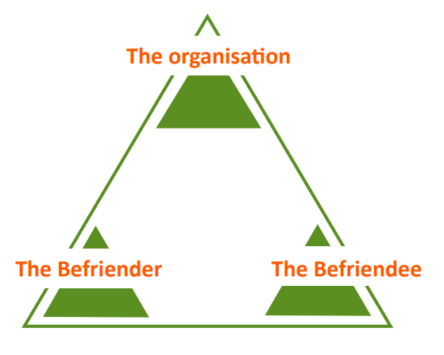
Within befriending, when we speak of confidentiality, we are normally referring to the obligation placed on befrienders not to disclose information about befriendees to third parties. Therefore, as a befriender, you are not at liberty to speak about your befriending relationship, share any personal details about them or discuss anything they have told you during visits or contact, with other people. There is one important exception to this – the Lead Befriender.

You have a responsibility to share everything with the Lead Befriender. This means that your befriendee can never ask you not to tell them something. They will know from the beginning of their involvement with the organisation that you have to pass everything on to the Lead Befriender. The minimum unit of cooperation and confidentiality in a befriending service and the befriending relationship consists of the befriender, the befriendee and the organisation. This is what is referred to as the Befriending Triangle.

Reporting Procedures
At The Isaiah Project you will need to email a weekly progress report to the Lead Befriender by the end of each week. The subject heading should read Progress Report Week Ending xxx.

Your report helps to keep the Lead Befriender informed of each resident’s progress and offer any advice if needed. It also helps the Lead Befriender:
- understand the issues you may be dealing with and put in extra support where necessary
- see if there are any common issues or concerns across the project and to plan training

The report should include the following:
Good news
Any personal / relationship issues
Any property issues
Any financial issues

Prayer Requests
One thing that sets us apart from most other befriending services is the power of prayer. Not only are we able to pray for our residents as individuals but we also have the benefit of prayer supporters who pray for our residents on a weekly basis. They are really keen to see God move in the lives of all of our residents and so they can do this each befriender must forward their prayer requests to our prayer coordinator on a weekly basis. This should be completed at the same time as your weekly progress report. (The prayer coordinator understands the need for confidentiality and will only forward the details needed by the prayer supporter.)

Sometimes what we need to pray for is very clear, at other times it is less so. Even if there is nothing new to pray for, or things are going well, a prayer request is still needed. Ideas for these times could be:
Continued prayers for health or financial breakthrough
Prayers that things continue to go well
Prayers for spiritual breakthrough

If emergency prayer is needed, please forward a separate prayer request through to the prayer coordinator or Lead Befriender.

Office Support

The office is there to support both you and the resident. The roles that you may encounter are as follows:

Operation Assistant – this role offers support to the Operations Manager / Lead Befriender and deals with queries that come in from yourselves or our residents. The role deals with issues such as moves, new residents, grant applications, helping out with Open House / Skill Groups, supporting our residents with forms etc.

Resident’s Finance Officer (RFO) - this role deals with all financial matters for the resident, from Housing Benefit queries to helping a new resident apply for the Essential Living Fund. If a resident tells you of a change to their financial circumstances e.g. starts or finishes work, Universal Credit changes, changes to their PIP award, cannot make their rent top up payments etc you should let the RFO know immediately. The resident should also know to tell the RFO.

If you know that your resident is really struggling financially you should advise them to contact the RFLO to discuss how we may be able to help.

Properties - We have a Properties Manager and a Property Admin to help maintain the upkeep of our properties and also deal with residents utilities. If you or your resident need to raise a property or utility issue please contact properties directly. Properties will arrange for any repairs to be made and keep you / the resident informed of any updates. We carry out / organise some of the maintenance ourselves (when it is within our remit), anything else is then passed to the agent / owner of the property.

This role also has an important part to play in resident moves, finding new properties and making sure that all leases are current.

The Shops / Van
We encourage our residents to volunteer at either one of our shops (Westcliff, Southchurch and Shoebury) or on the van. Should they wish to do this, please contact the Lead Befriender.

As part of living in Support Exempt Accommodation we can help our residents with the cost of buying / replacing essential items for their home (beds, sofas, wardrobes, etc). We can split the cost 50/50. To make sure that their need fits the criteria please:
- make sure that the item does need replacing
- advise the lead befriender who will authorise it (they will then let the shop know)
- advise the resident they can now go to the shop who will have their name and the details of what they need

